**GenC FTE Deployment Consent form**

I …Bandi Yuktha Reddy………., will be obliged to abide by, acknowledge, and agree to the following:

1. Place of Employment

I may be employed at any one of Cognizant's offices as per business requirements. The Company reserves the right to transfer me on a temporary or permanent basis to the other office locations, functions or departments within the Company and/or other affiliated entities and assign such other duties as may be deemed fit in the interest of the Company. The Company reserves the right to require me to work remotely from time to time as per the business needs or government mandate.

2. Work Schedule

a. The Company's normal working hours shall typically comprise of nine (9) hours per day, exclusive of any applicable break, subject to the limit of daily working hours, as prescribed by the applicable laws. The Company may require me to work for extended working hours/days including weekends, depending on the project requirements, business exigencies and/or for conscientious and complete performance of my duties and responsibilities towards the Company, subject to the limit of working hours as prescribed by the applicable laws. Any changes made to the Company's working hours shall be notified.

b. The Company may, at its discretion, vary the normal working hours or days for any employee or class of employees or for all the employees based on project requirements, Company policies and prevailing laws, as may be applicable from time to time/in consonance with any applicable laws for the time being in force. Any changes to be made to the above work timings or days shall be made by the Company at its sole discretion and notified in advance.

3. The Company may also require me to work on a shift basis. The shifts may be scheduled across 24 hours a day, 7 days a week and 365 days a year. The shift timings may change from time to time as per any Company policy and which will be notified to me in advance. My office timings shall be monitored by the Company through appropriate systems & processes, as updated from time to time and I shall ensure compliance to the processes and policies at all times.

Associate Name: ________Bandi Yuktha Reddy________ Associate ID : __2319933__

Location : __Coimbatore__ Signature : 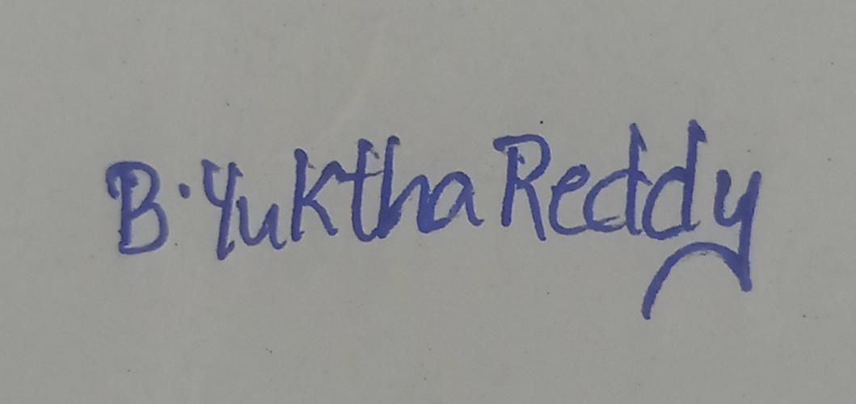

Date: *(05/04/2024)*